
Green University of Bangladesh
Department of Computer Science and Engineering (CSE)
Faculty of Sciences and Engineering
Semester: (Fall, Year:2025), B.Sc. in CSE (Day)

Lab Report NO# 02
Course Title: Web Programming Lab
Course Code: CSE 302 Section:232_D5

Lab Experiment Name: Implement a complex table using HTML and CSS
Student Details

Name |  | ID
1. | Md. Sohan Millat Sakib | 222902036

Lab Date : 15-10-2025
Submission Date : 22-10-2025
Course Teacher’s Name : Ms. Feroza Naznin

Lab Report Status
Marks: ………………………………… Signature:.....................
Comments:.............................................. Date:..............................

1. TITLE OF THE LAB REPORT EXPERIMENT

Implement a complex table using HTML and CSS
2. OBJECTIVES
The main objectives of this experiment are:
- To learn how to create structured tables using HTML tags such as <table>, <tr>, <th>, and <td>.
- To understand and apply the rowspan and colspan attributes for merging table cells effectively.
- To use CSS for styling tables, including borders, padding, and text alignment for better readability.
- To replicate a complex timetable layout accurately using only HTML and CSS..
3. PROCEDURE
- Understand the Table Design:
First, I looked carefully at the given table picture to understand how many rows and columns it has. I also noticed where to merge cells using rowspan and colspan.
- Write Basic HTML Structure:
I started with the basic HTML tags — <!DOCTYPE html>, <html>, <head>, and <body>.
Then I added a heading and started my table using the <table> tag.
- Create Table Rows and Columns:
I used <tr> for rows, <th> for headings, and <td> for normal table data.
I used rowspan and colspan to merge some cells so that the layout looks exactly like the given image.
- Use CSS for Styling:
I used CSS to give borders to the table using border and made them clean with border-collapse: collapse;.
I also added padding and text-align: center; to make the table look neat and easy to read.
- Use Flexbox for Proper Alignment:
In one part of the table (the “Tuesday” cell), I used Flexbox to arrange two topics vertically inside one cell.
I used CSS properties like display: flex, flex-direction: column, and justify-content: space-around to align the text nicely.
- Check the Output:
Finally, I saved the file as .html and opened it in my browser.
I checked if the table design, borders, and alignment all matched the given image correctly.

4. IMPLEMENTATION
Html code for complex table:

<!DOCTYPE html>
<html lang="en">
<head>
<meta charset="UTF-8" />
<meta name="viewport" content="width=device-width, initial-scale=1.0" />
<title>Table</title>

<link rel="stylesheet" href="./style.css" />
<style>
table,
tr,
td,
th {
border: 1px solid black;
border-collapse: collapse;
padding: 10px;
text-align: center;
}
</style>
</head>
<body>
<h2 style="color: red">Table</h2>
<table>
<tr>
<th rowspan="3">Day</th>
<th colspan="3">Seminar</th>
</tr>

<tr>
<td colspan="2">Schedule</td>
<td rowspan="2">Topic</td>
</tr>

<tr>
<td>Begin</td>
<td>End</td>
</tr>

<tr>
<td rowspan="2">Monday</td>
<td rowspan="2">8:00 am</td>
<td rowspan="2">11:00 am</td>
<td>Introduction to XML</td>
</tr>
<tr>
<td>Validity: DTD and Relax NG</td>
</tr>

<tr>
<td rowspan="3">Tuesday</td>
<td>8:00 am</td>
<td>11:00 am</td>
<td rowspan="3" style="margin: 0; padding: 0">
<div
style="
height: 100px;
display: flex;
flex-direction: column;
justify-content: space-around;
align-items: center;
margin: 0;
padding: 0;
"
>
<div
style="
display: flex;
justify-content: center;
align-items: center;
flex-grow: 1;
width: 100%;
border-bottom: 1px solid black;
"
>
X Path
</div>

<div
style="
display: flex;
justify-content: center;
align-items: center;
flex-grow: 1;
"
>
XSL Transformations
</div>
</div>
</td>
</tr>
<tr>
<td>11:00 am</td>
<td>2:00 pm</td>
</tr>
<tr>
<td>2:00 pm</td>
<td>5:00 pm</td>
<!-- <td>Validity: DTD and Relax NG</td> -->
</tr>

<tr>
<td>Wed</td>
<td>8:00 am</td>
<td>12:00 pm</td>
<td>XML Formatting Objects</td>
</tr>
</table>
<br />
</body>
</html>

5. TEST RESULT
Output of Table
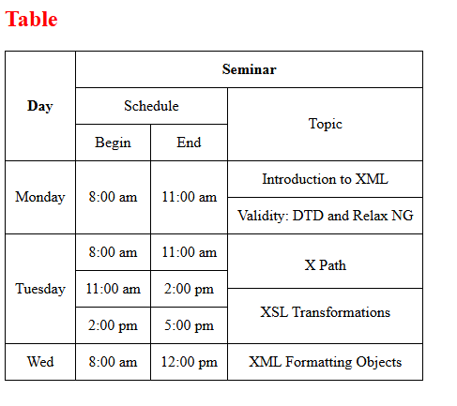
6. ANALYSIS AND DISCUSSION
In this experiment, I created a web page using HTML where I implemented a complex table. After solve this table I get confidence to make any kind of table what I want. After solving this table I get clear concept idea about table, colspan, rowspan. The most hard tricky part of this table I face more problem are to develop the `X Path` and `XSL Transformation` because there have to add two row using 3 row. I implemented that using flex.
7. SUMMARY:
In this lab, I created a seminar schedule table using only HTML and CSS. I used rowspan, colspan, and Flexbox to design and align the table properly. CSS was used for borders, padding, and neat layout styling..

